**Curriculum Vitae**

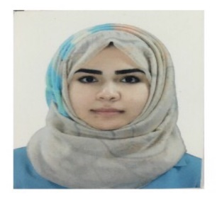

**Personal Information:**

Name: Afyan Dhyaa Naeem

Date of birth: 08 December 1994

Nationality : Iraqi

Mobile: 07714577803

Mail: [afyandeaa@yahoo.com](mailto:afyandeaa@yahoo.com)

Permanent address: Baghdad- Al- Ghazalia

**DEGREE OBTAINED:**

* B.c. in civil Engineering college of engineering- Al-Mansour University college class of 2015-2016
* A member in the Iraqi Engineers Union.

**Languages:**

* Arabic: Spoken & written (fluent-native).
* English: Spoken & written.

**Computer knowledge:**

* AutoCAD.
* Windows programs.
* Microsoft office programs and others.
* Internet.

**Responsibilities and Tasks:**

* Seeking for the venerable persons and doing the necessary assament for them.
* Indicating the most necessary needs for them and prepare the tables.